typescript

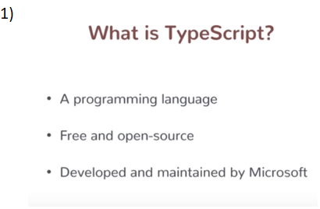

* 1. **Some problem with javascript**

Machine generated alternative text:
return -r b: 
"Xoush.i#, 
• LastN—' 
tumctinn 
f ncd 
21 
L"tN—: 

1. **Javascript still require because browser understand javascript language only**

Machine generated alternative text:
Any 
language 
Compilation 
JS 

Machine generated alternative text:
Development 
time 
TypeScript 
TypeScript 
compiler 
Runtime 
JS 

Machine generated alternative text:
TypeScript 
JS 
TypeScript 
compiler 
NodeJS 

1. **Typescript contain old javascript code and also some new features**

Machine generated alternative text:
TypeScript 
JavaScript 
types 
(and some 
other stuff) 

Machine generated alternative text:
So, TypeScript 
• Makes building these complex apps more 
manageable 
• Frameworks like Angular 2 is using it. 
More might in future 

1. **Setting up type script**

Visual studio editor

Install node js

Npm install typescript -g

**Unit -2 basic features and types**

Arrow function both are same

Machine generated alternative text:
var fn 
var fn 
• ( ) 'response'; 
• function() 
return response • . 
1 

**1) Introducing type declaration**

Note: open terminal in visual studio

View-open-view-terminal

1. Extension of typescript file :- a.ts
2. Compile typescript code: tsc filename execute javascript file :- node filename.js
3. Typescript allow type declaration of different variable

var a: number; to declare only number ( note datatype is postfix)

Var b boolean;

**2) Array and Tuples**

**Defining array of number types**

var myArr : number[];

myArr=[];

myArr=[1,2];

Note :- but if we want to assign in array first element is string and second is number then use the concept of tuple

Machine generated alternative text:
For array declaration, you specify the data type before the J. For tuple 
declarations, the data types are specified like elements inside the 

var myArr:[number,boolean];

myArr=[1,false];

**3 type erasure and error behavior**

**Point 1:** when compiler transpile typescript code to JavaScript code it removes all the typescript specific features

**Point** 2: if typescript code having error it warns developer to correct it but still it will compile code into javascript

since JavaScript don’t have this error

4) **typing with function**

Machine generated alternative text:
By default, TypeScript enforces that the argument counts in function 
calls exactly match function signature. 

**Case:-1 Optional argument (c ? )**

function add1(a:number,b:number,c?)

{

return a+b;

}

var sum=add1(1,3,"hello");

console.log(sum);

**Case:- 2 Note :** optional argument should be at last but it can be more than one

function add1(a:number,b:number,c=2)

{

return a+b+c;

}

var sum=add1(1,3);

Defalut value of c is 2 which is optional parameter if didn’t pass any value from function

. If pass optional parameter value from function then that will be considered

**Case:- 3**

Machine generated alternative text:
function add(a. b, c • 
return a • b c; 
var • add(l, 2, 3); 
console. tog( sun); 

Machine generated alternative text:
Here, argument d is a number and is optional. So it doesn't need to be 
passed. But if it is passed, it should be a number. 

**Case 4:**

Machine generated alternative text:
func t ion 
retu 
var st. 
a: mnber, 
: mnber, c: 
console. log( sun); 

The return type of function can also be a number

**5)Implicit typing**

**Implicit typing with variable declaration**

var a : 10;

var b :true;

var c :"hello";

a=false;

Machine generated alternative text:
If you don't explicitly declare a variable type, but you assign a value with the declaration, 
TypeScript implicitly assumes the type from the value being assigned! 

**Implicit typing with function calls**

function greet() : string{

return "hello";

}

var greeting =greet();

Machine generated alternative text:
In Visual studio coder you can hover your mouse over a variable to see 
what type TypeScript thinks it is. 

**NOTE**

Implicit typing will work when assignment is on same line as declaration

**6) Any and union types**

**Case 1: any ( any type of variable we can assign)**

**Example:**

var a:any;

a="saurabh";

a=1;

**Case 2 : union types ( want only 2 variable)**

var a:number | boolean;

a=false;

a=1;

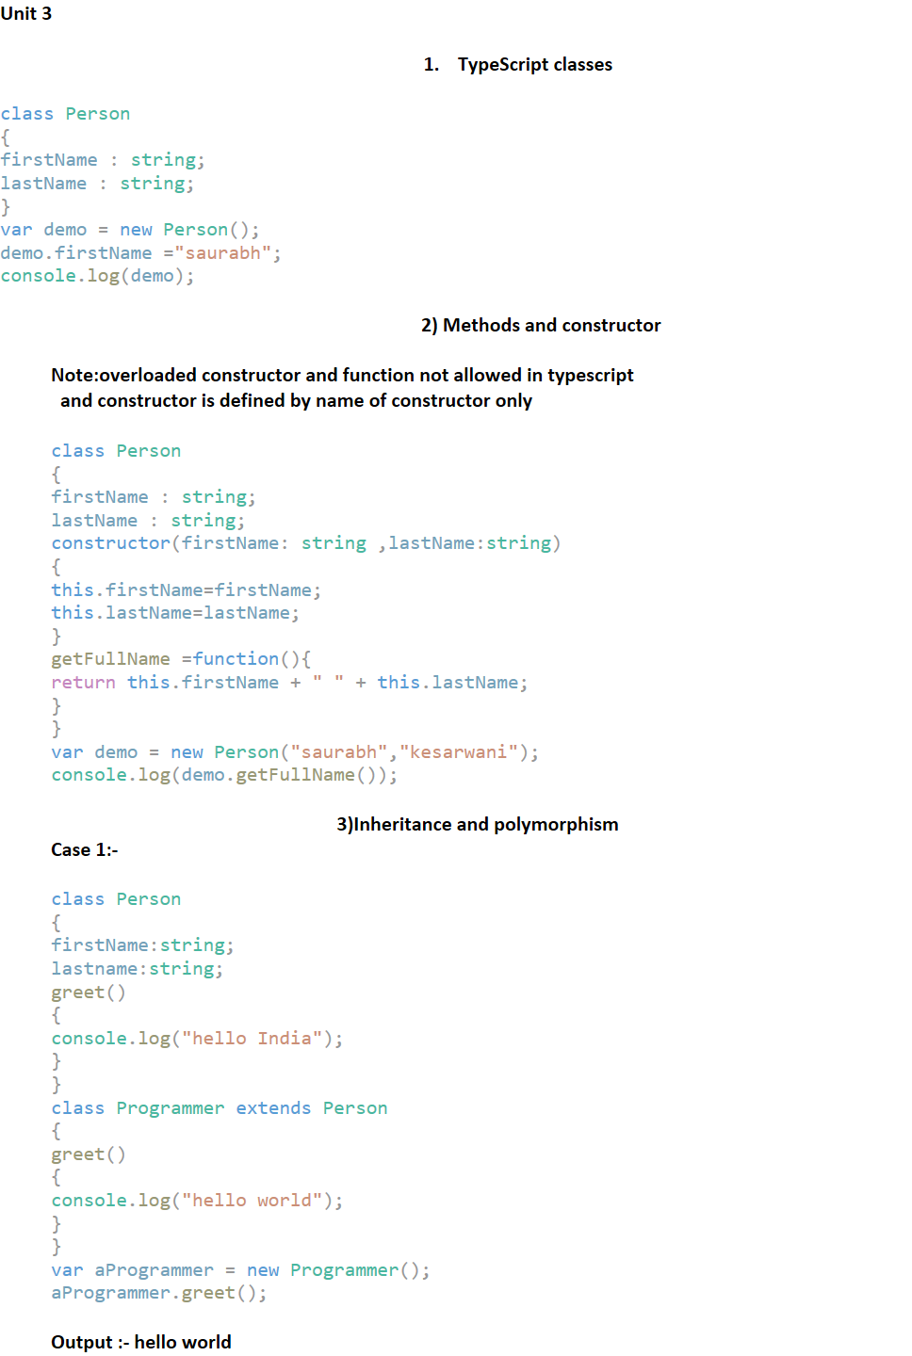  
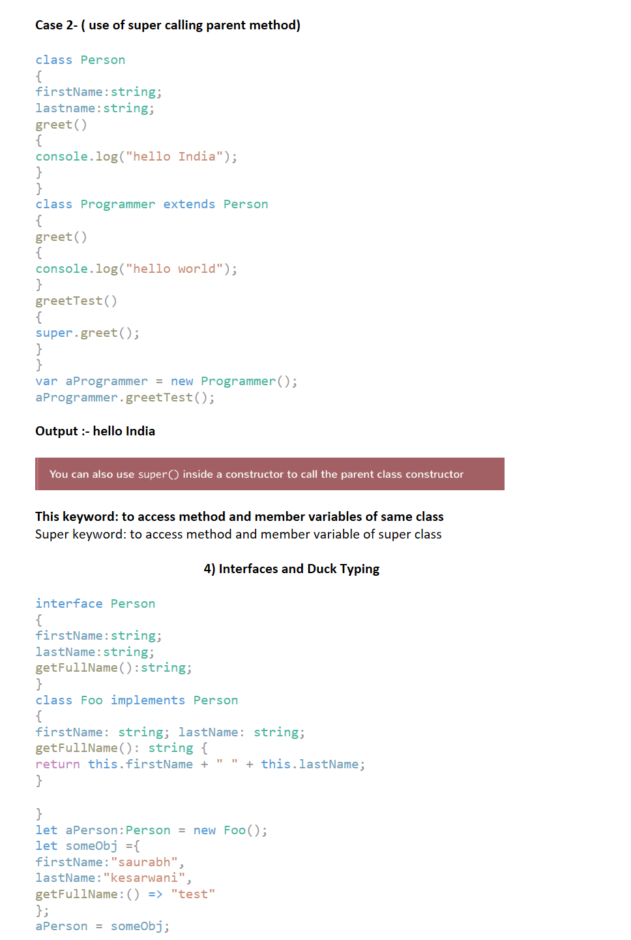  
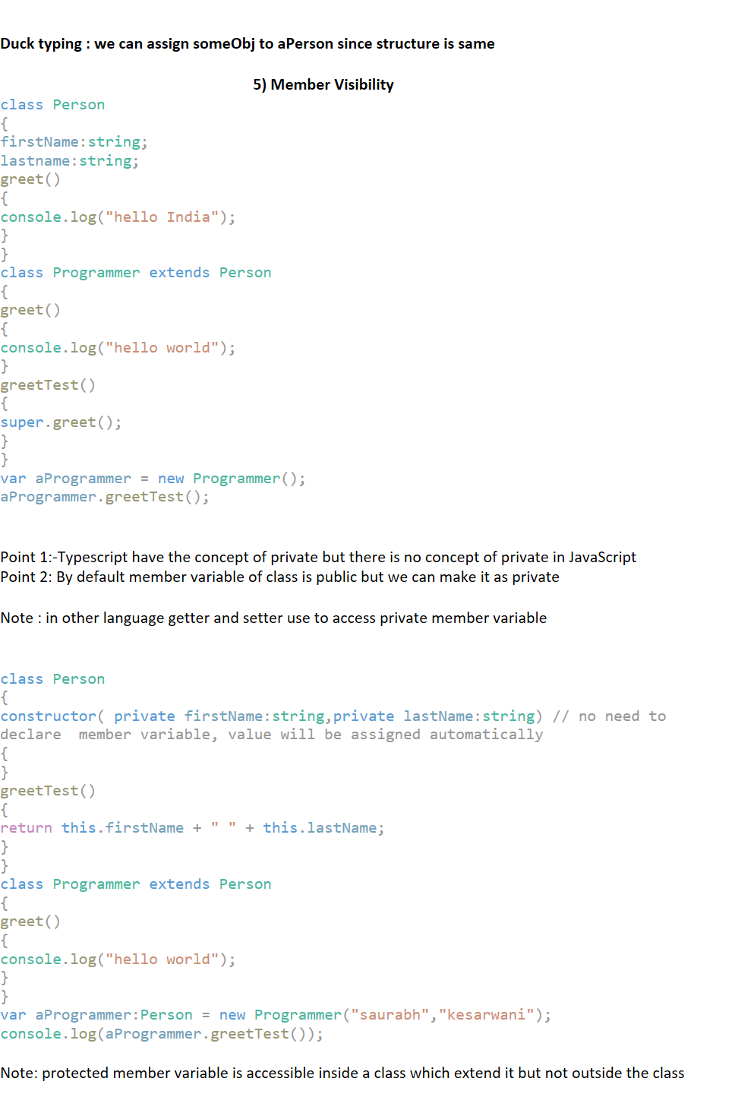  
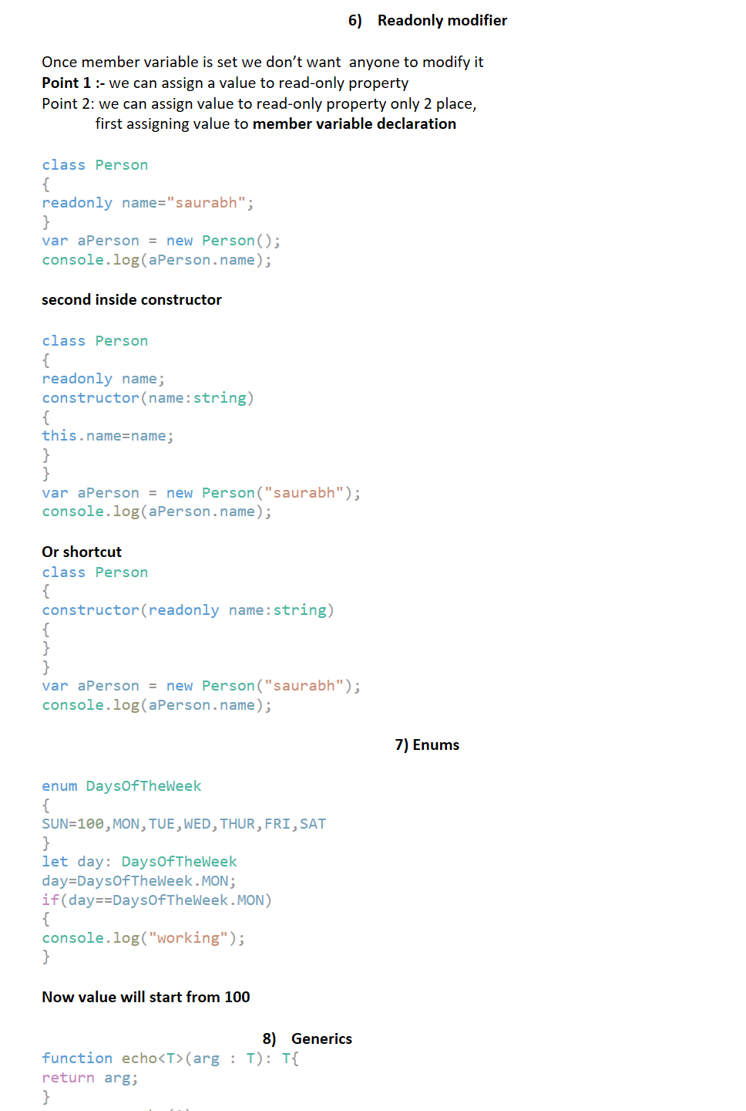  
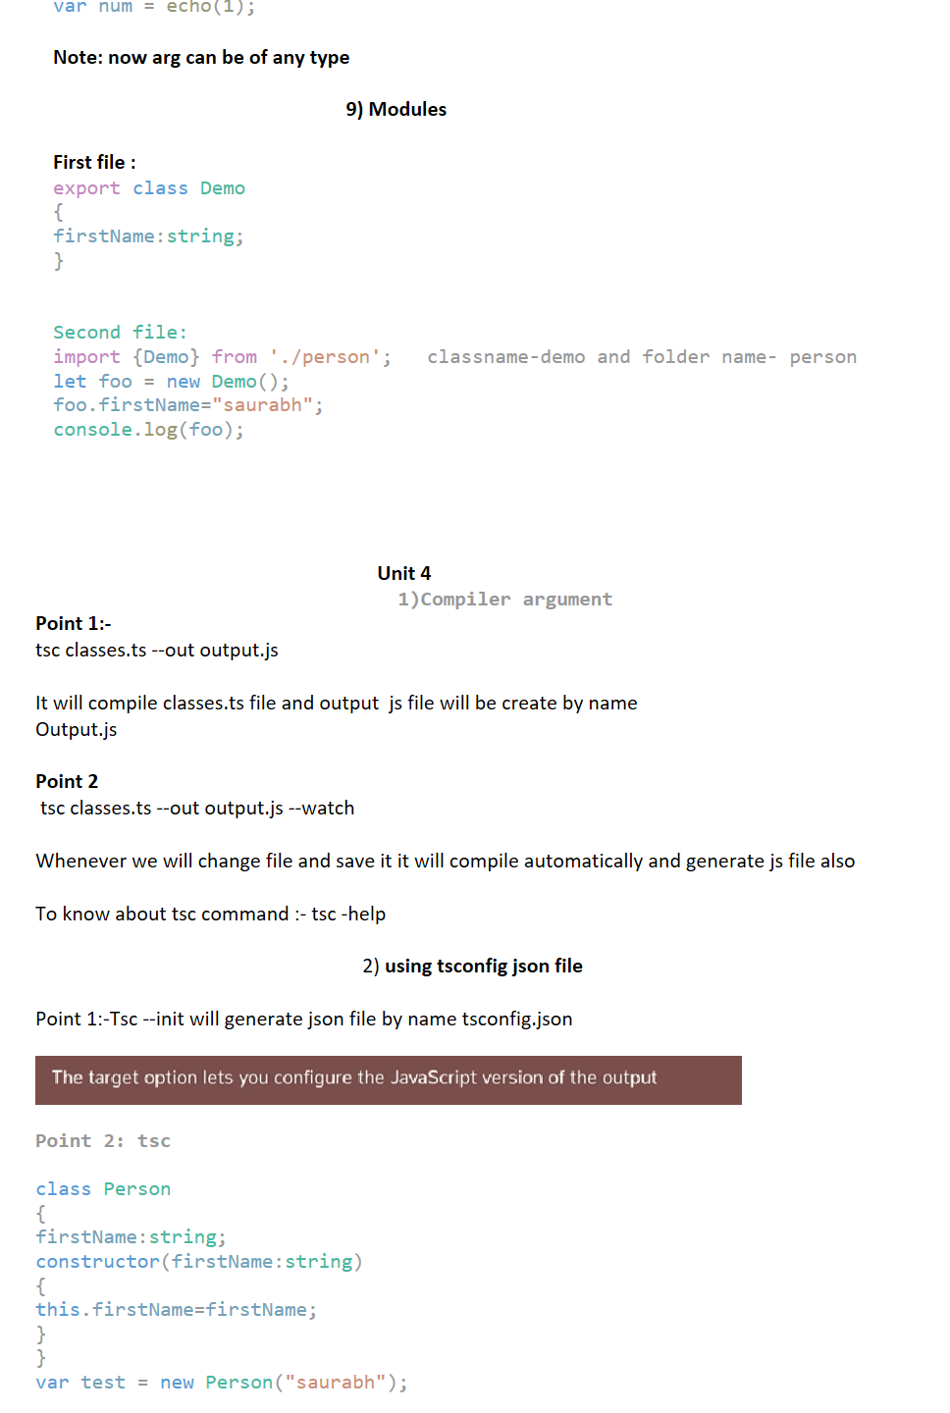  
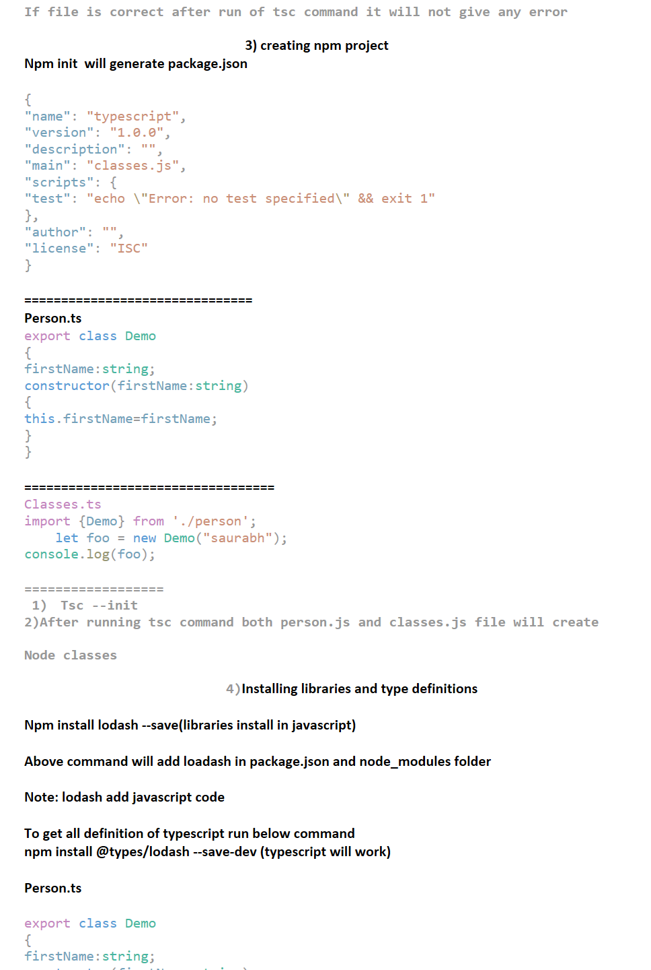  
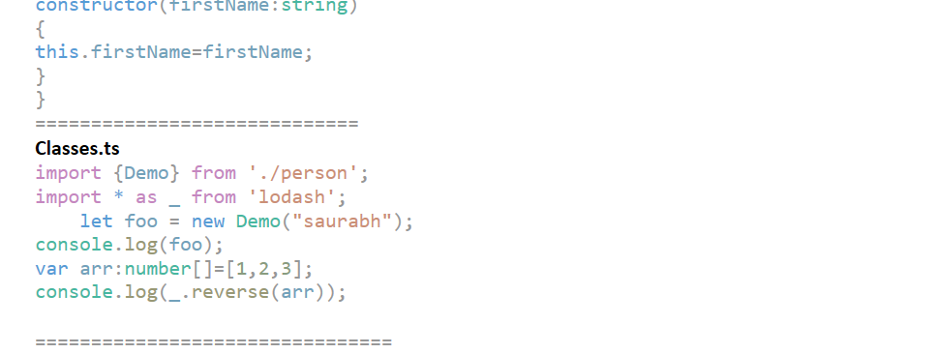

**Unit -5**

**1)Setting up the project**

**a)Npm init -------------generate package.json**

1. **Tsc --init--------------generate tsconfig.json**

Machine generated alternative text:
package.json 
le 
11 
12 
13 
14 
15 
16 
17 
18 
tsconfig.json x 
preserve 
"declaration" . 
true, 
"declarationMap" . 
true, 
" sourceMap' 
true, 
index.ts 
root 
/ * Generates a sourcemap tor eacn 
/ * Generates corresponding 
' . map' 
/ * Concatenate and emit output to 
1 Of 7 
corresponding 
file. * / 
single file. */ 
t Ile 
"outFi1e 
"outDir" : 
" rootDir" : 
" . / out ' 
" ./src" 
/* Redirect output structure to the directory. * / 
/* Specify the root directory of input files. Use to contro 
/ * Enable project compilation * / 
/ * Do not emit comments to output. * / 
/ * Do not emit outputs. * / 
" composite" 
true, 
" removeComments ' 
true, 
"noEmit" : 
true, 

d)

Machine generated alternative text:
File Edit 
Selection View 
EXPLORER 
OPEN EDITORS 
Go 
Debug 
Tasks 
Help 
package.json X 
tsconfig.json 
index.ts 
root 
&& exit 1" 
* 
No Results 
1 
2 
3 
4 
5 
6 
7 
8 
9 
11 
12 
" name " 
"version " 
"typescriptdemo" , 
package.json 
tsconfig.json 
TS index.ts src 
TYPESCRIPTDEMO 
out 
TS index.ts 
package.json 
tsconfig.json 
"I.e. e" , 
"description " 
"main" . 
"scripts " . 
's 
test" : 
" author" : 
"license" 
" index . js " 
" "tsc && 
"echo 
"ISC" 
node out/index.js' , 
"Erro 
n 
specifiedk" 
x 
1: powershell 
PROBLEMS OUTPUT DEBUG CONSOLE 
TERMINAL 
PS C: XAFM ProjectXTypeScriptDemo) npm 
start 

**Tsc(typescript compiler) for compile and node out/index.js for run since index.js given in package.json**

**Note: we change root directory for source file and output directory in tsconfig which contain**

**Js file**

1. **Npm start**

**2) Installing dependencies**

**(Adding external libraries and type definition)**

**a)install lodash : npm install request lodash --save**

1. **Npm install @types/lodash @types/request --save-dev**